**RENESENG 4th Year Deliverables**

User Guide for Resource Mapping for Supply Chains Optimisations

March 2018

Dr. Nathanial Cooper

Marie Curie ITN Experienced Researcher

ER 3.2

Imperial College London, Chemical Engineering, London

User Guide for the Resource Mapping for Supply Chains Optimisations

As a prerequisite, QGIS must be downloaded and installed. QGIS is available from the qgis.org website at <https://www.qgis.org/en/site/forusers/download.html>. It is recommended to select either the “Latest Release” or “Long Term Release” rather than the OSGeo4W version, as the OSGeo4W version is far more complex, more than needed.

1) To use the algorithm, a new Project must be created, and the grid shapefile must be added to the project. To do this, open QGIS, and select New in the upper left

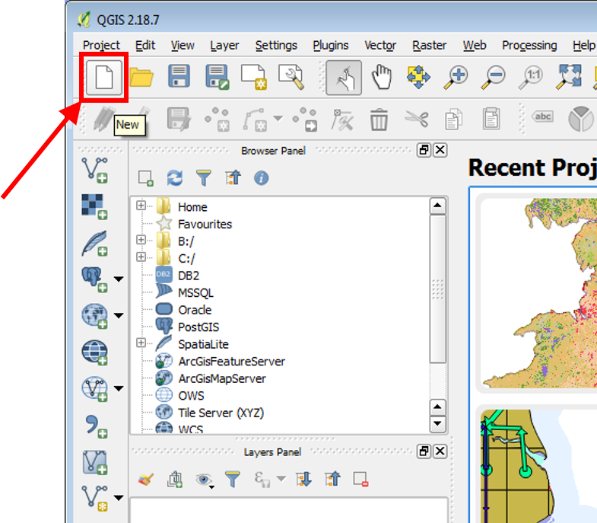

2) To add the region of interest shapefile, select the *Add Vector Layer* button from the left side panel

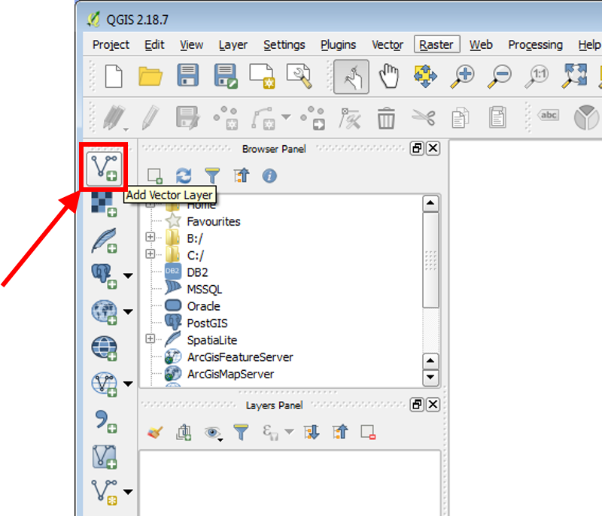

3) Select *Browse* in the “Add vector layer” window that appears

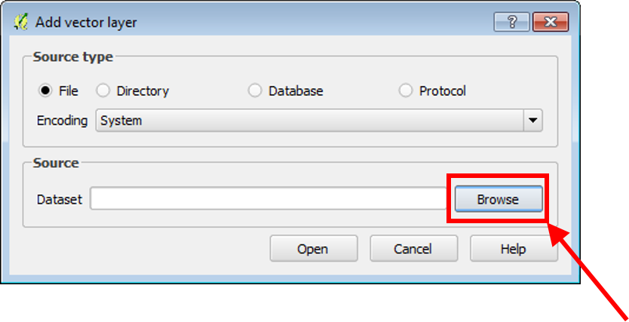

4) Find the location of the region of interest shapefile and open it using the standard dialogue.

5) Now select *Open* in the “Add vector layer” window

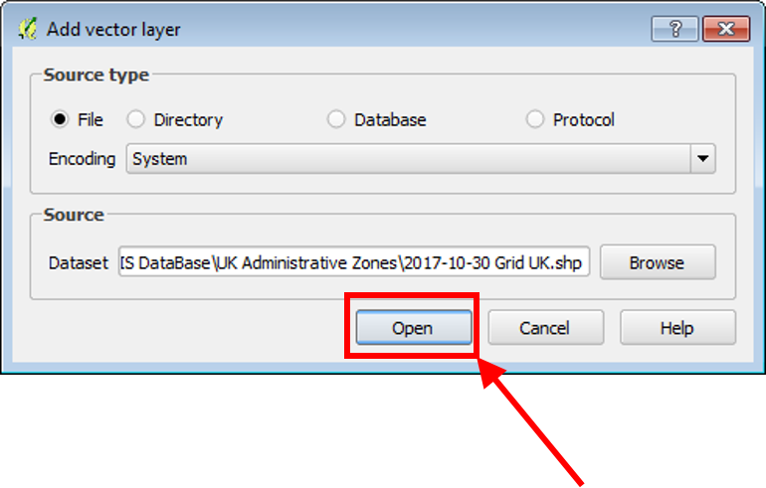

6) To add the land use raster, select the *Add Raster Layer* button from the left side panel

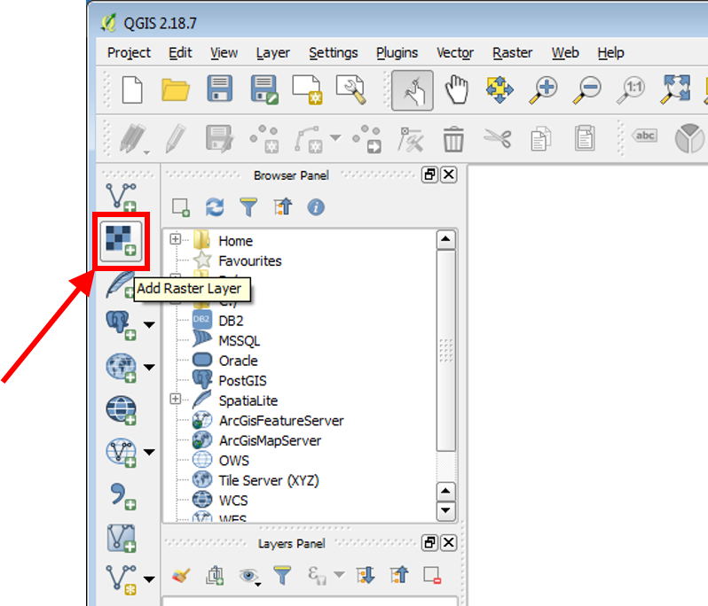

7) Find the location of the land use raster and open it using the standard dialogue.

8) Repeat steps 6 and 7 for the constraint raster and each of the biomass yield rasters that will be included.

9) Now that the files have been inserted, we can prepare to include the algorithm. To do this, activate the Processing Toolbox by selecting the *Processing* top menu, and choosing *Toolbox* from the dropdown menu

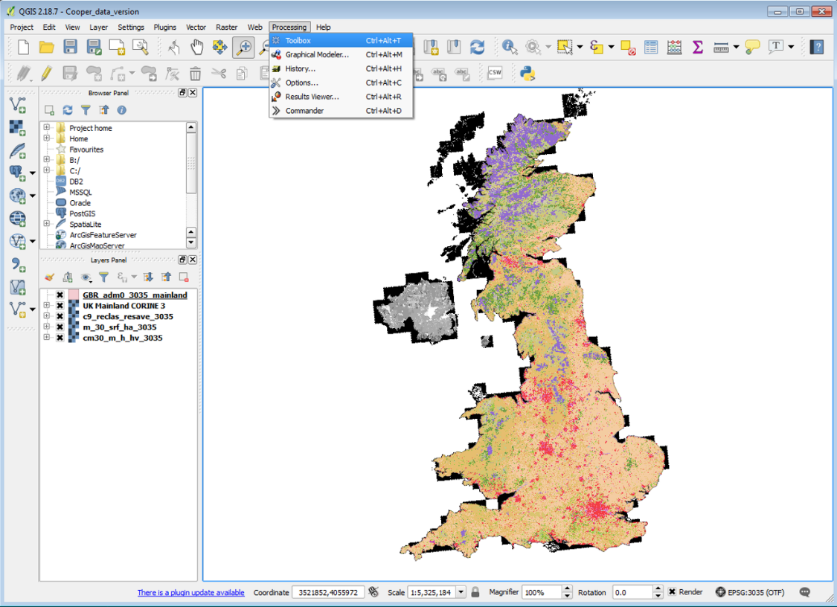

-------------

From here, 2 paths can be taken to get the code – either copy & paste the code or download it from GitHub and add the script.

Copy and Paste

10a) Expand *Scripts*, then *Tools*, then select *Create new script* under the “Processing Toolbox” window

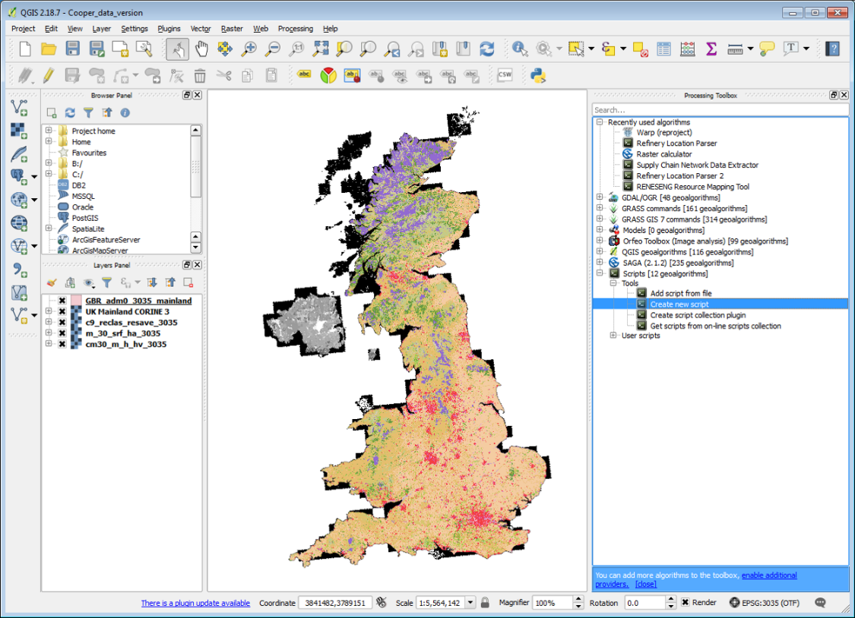

10b) Find the source code on GitHub (currently XXX). Copy and paste just the code into the new script window

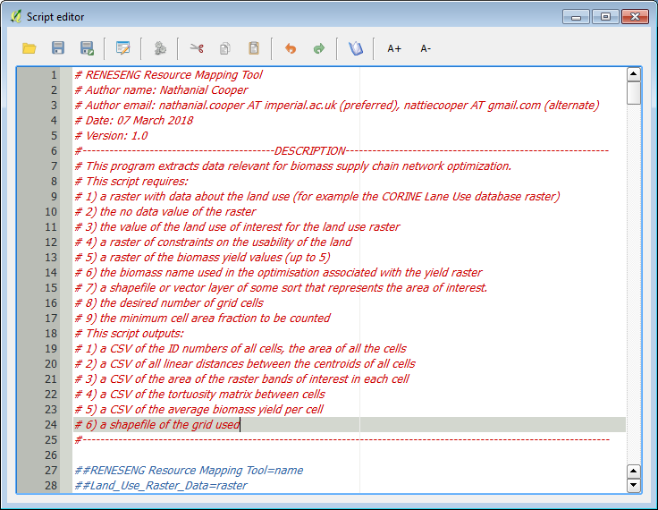

Download

10a) In a web browser, navigate to the GitHub page for the project

(XXX) and select the *Clone or download* button, and choose to *Download ZIP*. Unzip the zip to wherever you would like.

IMAGE HERE

10b) In QGIS, expand *Scripts*, then *Tools*, then select *Add script from file* under the “Processing Toolbox” window

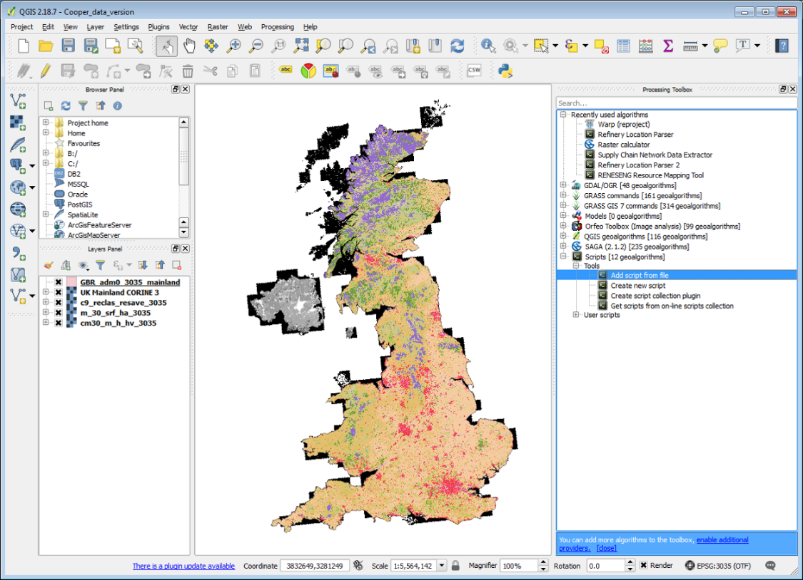

10c) Navigate to the script from the ZIP file and open it.

-----------

11) The next step is to open the python console. Click on the *Python Console* button in the upper middle-right side of the window

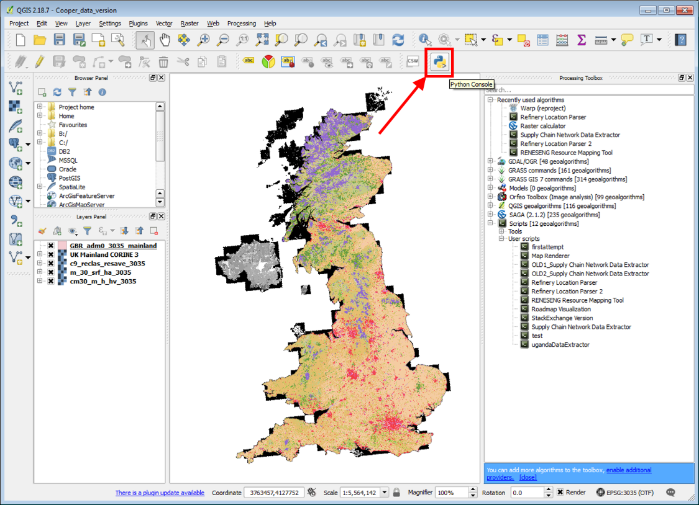

This will open the Python Console, which provides useful information on the program as it runs.

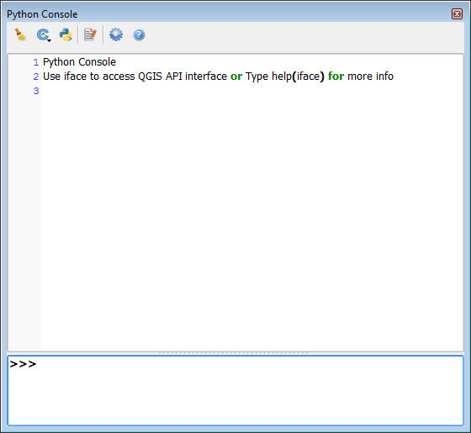

12) Now it is possible to run the algorithm. To run it, select the *Run Algorithm* button that looks like gears in the “Script Editor” window

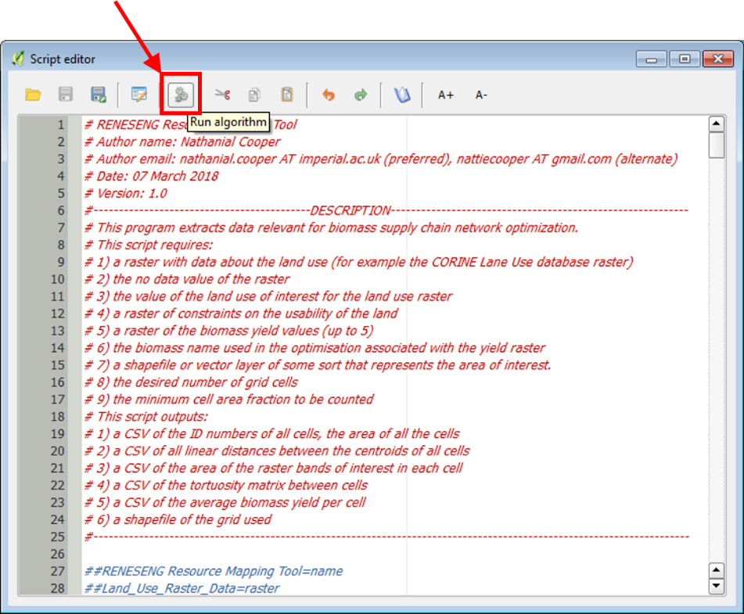

13) Enter the information requested by the algorithm dialogue, “RENESENG Resource Mapping Tool”. If it is not already selected, choose the land use data set from the *Land Use Raster Data* dropdown

14) Enter the no data value for the land use data set in the *No Data Value* text box. This must be a number.

15) Enter the raster value of the land use type of interest associated with the land use data set in the *Raster Value of Interest separate values by commas* text box. This must be a number or list of numbers separated by commas.

16) If it is not already selected, choose the constraint layer from the *Constraint Layer* dropdown. This is optional.

17) If it is not already selected, choose the biomass yield data set from the *Bioyield Map A* dropdown. This is optional.

18) Enter the name of the biomass associated with Bioyield Map A as it appears in the optimisation in the *Bioyield Product A* text box. This is optional.

19) Repeat 17 and 18 for Bioyield maps and products B – E, should you need them. You do not need to fill all the spaces.

20) If it is not already selected, choose the region of interest shapefile from the *Region Shapefile* dropdown

21) Enter approximate desired number of cells for the cellular grid that will be used to analyse the data in the *Desired Number of Cells* text box. This will not be exact, but +/- 5%.

22) Enter the minimum area fraction that cells must be relative to the largest cell in order to be counted (between 0 and 100, where 0 includes all cells and 100 includes only cells that are the same size as the largest cell) in the *Only count cells with at least x percent of the area of the largest cell where 0 includes all cells* text box.

23) To select the location to save the CSV of cell areas, labelled *Ouput Cell area*, click on the ellipses button adjacent to text box, and select *Save to File* from the dropdown. Use the standard save dialogue to indicate where the file should be saved.

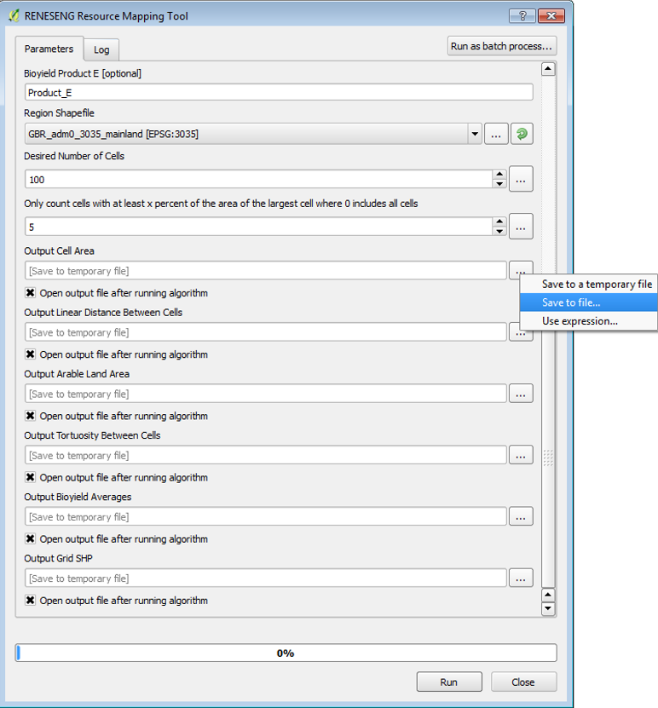

24) Repeat step 23 for each of the remaining outputs, including *Output Linear Distance Between Cells*, *Output Arable Land Area*, *Output Tortuosity Between Cells*, *Output Bioyield Averages*, and *Output Gird SHP*. The *Open output file after running algorithm* checkbox can be unchecked for the grid SHP.

25) Click the *Run* button at the bottom of the dialogue box. This can take anywhere from 5 – 20 minutes or more to run, so be patient.

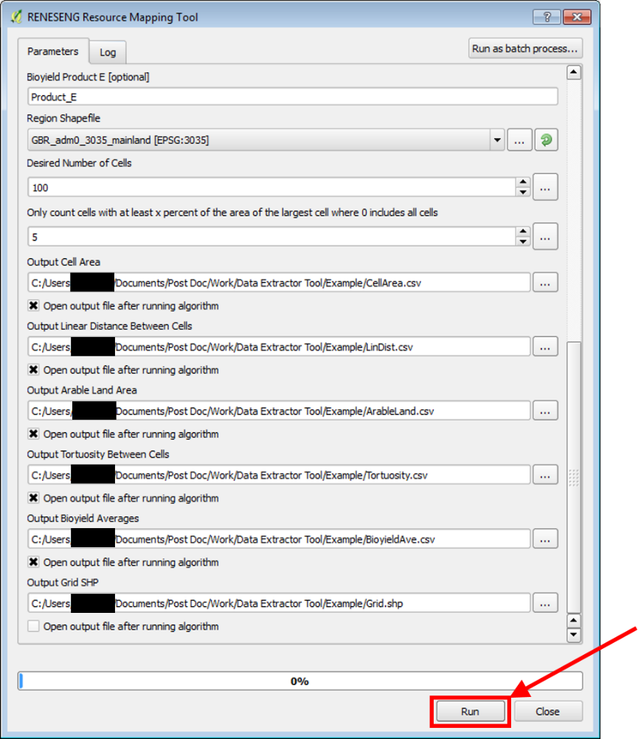

26) Close the dialogue after it has finished running, if it is still open (it is fine if it closes itself)

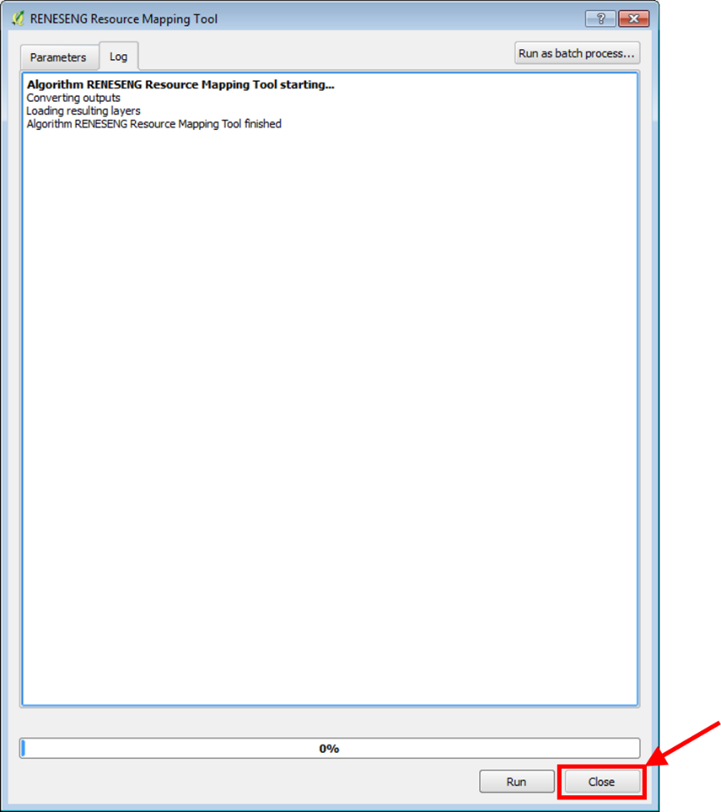

27) The python console provides information about the time the algorithm took to run, and the number of grid cells created.

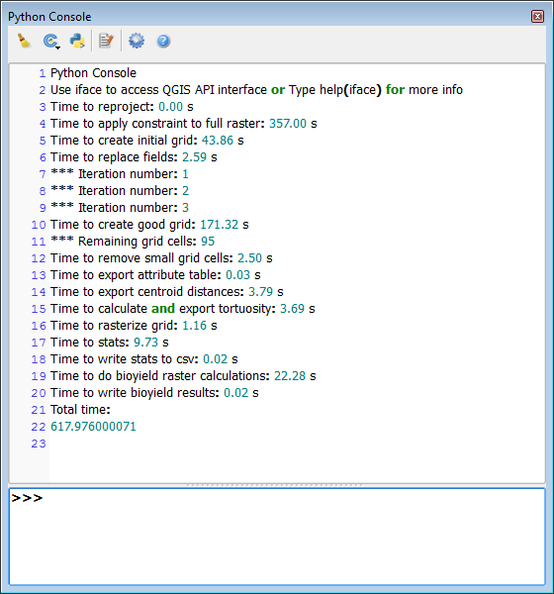

28) All generated data sets are available in their pre-specified save locations, as well as in the *Layers Panel* on the left side.

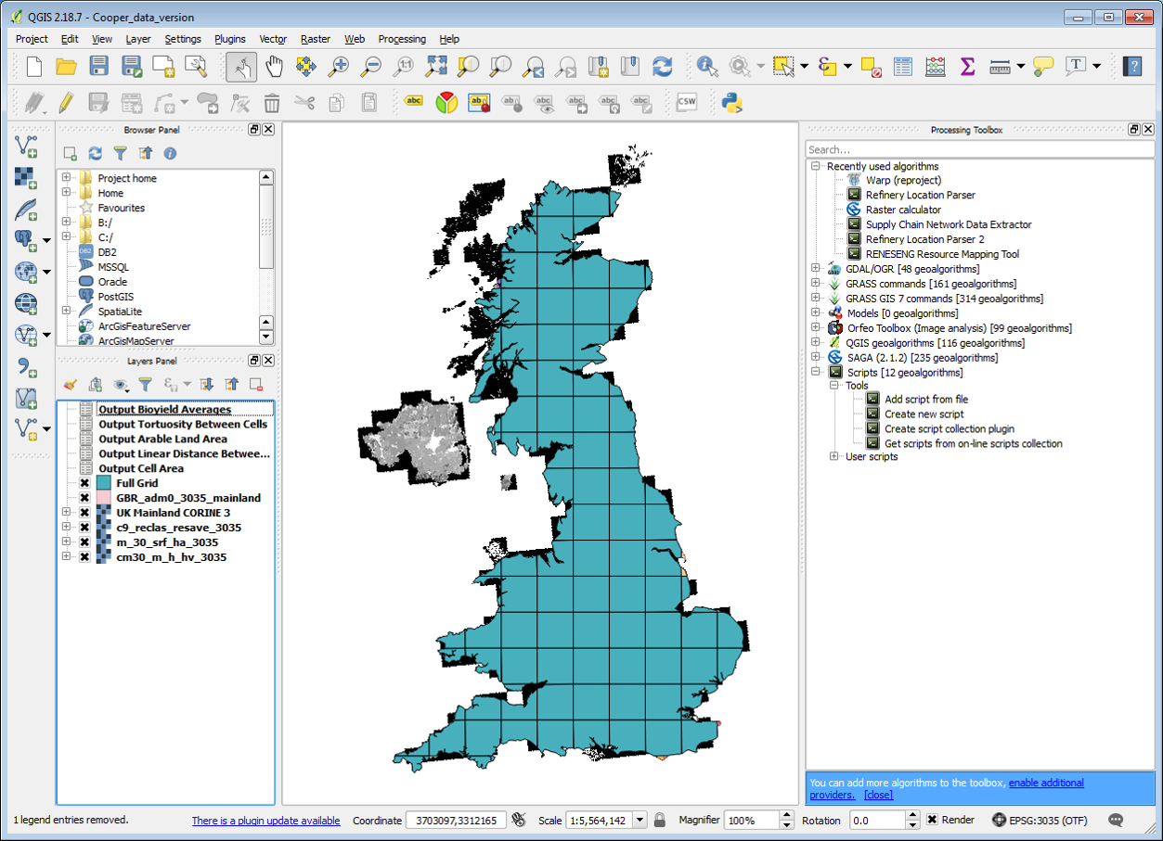

29) The contents of the file may be examined by right clicking on a file in the *Layers Panel* and selecting *Open Attribute Table*

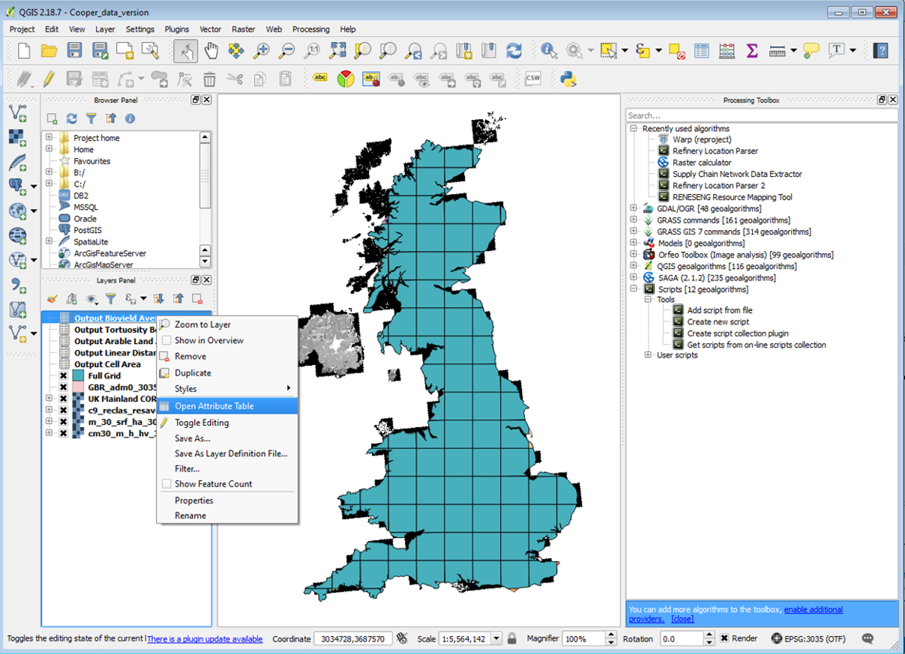

This opens another window which displays the contents of the file called the *Attribute Table*

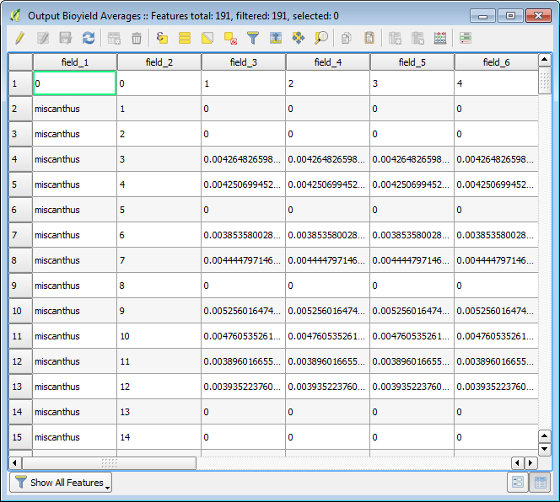

30) The csv outputs can be viewed by opening the source files with an appropriate browser, such as excel. To do this, they must be either removed from the QGIS project, or QGIS must be closed first. To remove a file from QGIS, click on the file in the *Layers Panel*, then select the *Remove Layer/Group* button from above. The source file may now be opened in Excel.

